**HOLD**

**Breathe out ouout**

**Breathe in**

**Breathe in**

START HERE

**Be Kind**

**To your Mind**

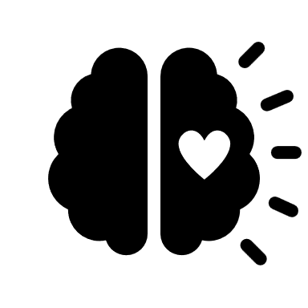

**Breathe out**

**Breathe out**

**Breathe in**

**Breathe out**

**Breathe in**

**Breathe out**

**Breathe in**

**HOLD**

**HOLD**

**Breathe out**

**HOLD**

**HOLD**

**HOLD**

**Breathe in**